Book Review
The Invisible Life of Addie LaRue
By V.E. Schwab
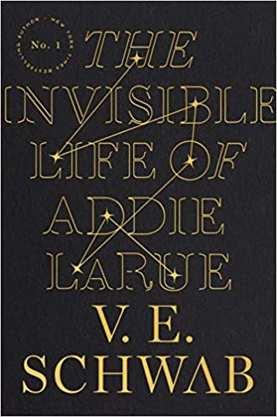

May Contain Spoilers

Let me start by saying this might be my favorite book of the year. It’s only February, so only time will tell, but this one is going to be hard to top.
I will further go on to say this read is not for everyone. The repeated words or phrasing may feel redundant to some readers and the lack of “big” events may make this just not an ideal book for all. For me, it was a beautiful torture, a lovely lamenting sensation I could not get enough of, and characters who didn’t conform to the standard love interests.
The book follows Adeline LaRue, born in Vellon, France, many years ago. It documents her time story through time, and we learn that Adeline, a.k.a Addie has lived for 300 hundred years after making a deal with a god after nightfall—Luc.
From the beginning, Addie is fiercely independent, and desires to live a life of her own, to be unattached, and mostly unmarried.
I loved her character, from her sheer will and stubbornness, to her softer qualities. Addie was a multi-faceted character and I sincerely enjoyed reading her and her continued triumphs even after many hardships, as she learned to live an invisible life.
See, no one can remember Addie, not even her family. Once she is out of her sight, they no longer remember who she is or that they’ve met her. Leaving Addie to live a lonely existence with no way to leave her mark on the world or the people she interacts with along way…but, Addie learns that ideas have weight, ideas have power, and when you plant an idea—it has the ability to transform into something all its own. Art.
Addie’s invisible existence is set in motion by Luc, a devilish answerer of prayers and giver of wishes. But a deal with Luc always comes at a cost—your soul. And my, oh my, will Luc come to collect his payment. Luc is the standard dark-haired, emerald eyed, smooth talking, RUIN YOUR LIFE type. And I mean that in the most literal sense. Fortunately, for myself, I did not fall prey to Luc’s sly charms and pull you in/push you away nature. As the years goes on and on, it appears that the god of the dark may….have feelings for Addie.
Along the way Addie meets Henry, the lovable bookish type. I adored Henry. The more I read about him, his “feeling too much” and his perceived imperfections—the more I loved his character. I would fall upon a sword for Henry. I love that Henry is depicted as not your neurotypical character, he has what appears to be bouts of depression or “storms” as the book calls them. His emotions felt so real to me. His lacking direction, and his feeling of not being enough—to me that’s something so many people experience, and I connected with his realness in these moments. Henry’s deal came as an absolute shock to me. I can say—I didn’t see it coming until the truth tumbled from his lips and that it all made so much sense. The things someone might give up to feel like they are enough is emotional.
In the end, Addie and Henry find something together that feels tangible and wholesome. A fresh purpose for the both of them and a way for Addie to tell her stories, but time is precious and fleeting, as it always is.
Favorite Quotes:
“Books, she has found, are a way to live a thousand lives--or to find strength in a very long one.”
―V.E. Schwab’s The Invisible Life of Addie LaRue

“Because time is cruel to all, and crueler still to artists. Because visions weakens, and voices wither, and talent fades.... Because happiness is brief, and history is lasting, and in the end... everyone wants to be remembered”
― V.E Schwab’s The Invisible Life of Addie LaRue

“Take a drink every time you hear you’re not enough.
Not the right fit.
Not the right look.
Not the right focus.
Not the right drive.
Not the right time.
Not the right job.
Not the right path.
Not the right future.
Not the right present.
Not the right you.
Not you.
(Not me?)
There’s just something missing.
From us.
What could I have done?
Nothing. It’s just…
(Who you are.)
I didn’t think we were serious.
(You’re just too…
…sweet.
…soft.
…sensitive.)
I just don’t see us ending up together.
I met someone.
I’m sorry
It’s not you.
Swallow it down.
We’re not on the same page.
We’re not in the same place.
It’s not you.
We can’t help who we fall in love with.
(And who we don’t.)
You’re such a good friend.
You’re going to make the right girl happy.
You deserve better.
Let’s stay friends.
I don’t want to lose you.
It’s not you.
I’m sorry.”
―V.E. Schwab’s The Invisible Life of Addie LaRue

“You know,” she’d said, “they say people are like snowflakes, each one unique, but I think they’re more like skies. Some are cloudy, some are stormy, some are clear, but no two are ever quite the same.”
—V.E. Schwab’s The Invisible Life of Addie LaRue

“His heart has a draft. It lets in light. It lets in storms. It lets in everything.”
―V.E. Schwab’s The Invisible Life of Addie LaRue

5 STARS
*****

